5G/6G Communication Systems- ECA5601 (LAB)
Student Name: : A.SAI KIRAN
Reg no: 192312672LB

Experiment 7: Analog Beamforming Analysis Using MATLAB
Aim:
To analyze the performance of analog beamforming by studying beamforming gain, beam width,
and main lobe direction using MATLAB.
Objectives:
1. To analyze the beamforming gain achieved by varying the number of antenna elements in
an analog beamforming system using MATLAB.
2. To compare the beam width of an antenna array for different beamforming configurations
using MATLAB.
3. To analyze the main lobe direction by steering the antenna array beam to different angles
using MATLAB.
Software Required:
• MATLAB
Objective 1:
Program:
clc;
clear;
close all;
antennas = [2 4 8 16 32]; % Number of Antenna Elements
gain = 10*log10(antennas); % Beamforming Gain (dB)
figure
bar(antennas, gain)
grid on

xlabel('Number of Antenna Elements')
ylabel('Beamforming Gain (dB)')
title('Beamforming Gain for Different Antenna Array Sizes')
Output:
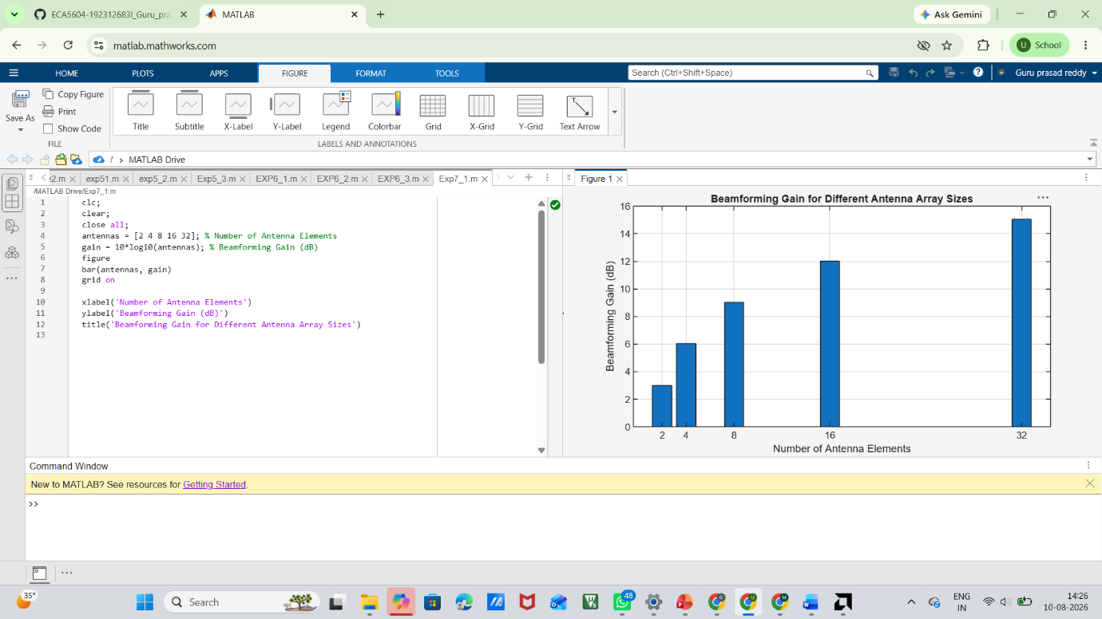

Objective 2:
Program:
clc;
clear;
close all;
antennas = [2 4 8 16 32]; % Number of Antenna Elements
beamwidth = [90 45 22.5 11.25 5.625]; % Beam Width (degrees)
figure
plot(antennas, beamwidth,'o-','LineWidth',2)
grid on
xlabel('Number of Antenna Elements')
ylabel('Beam Width (Degrees)')
title('Beam Width for Different Antenna Array Sizes')
Output:
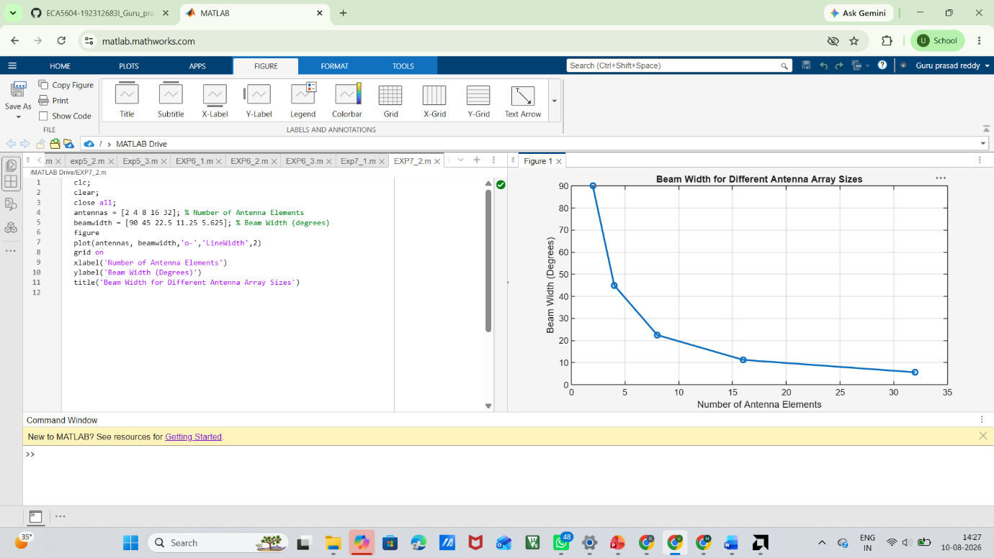

Objective 3:
MATLAB Code:
clc;
clear;
close all;
theta = [-60 -30 0 30 60]; % Main Lobe Direction (degrees)
gain = [1 1 1 1 1]; % Constant normalized gain
figure
polarplot(deg2rad(theta), gain, 'o', 'LineWidth', 2)
title('Main Lobe Direction in Analog Beamforming')

Output:
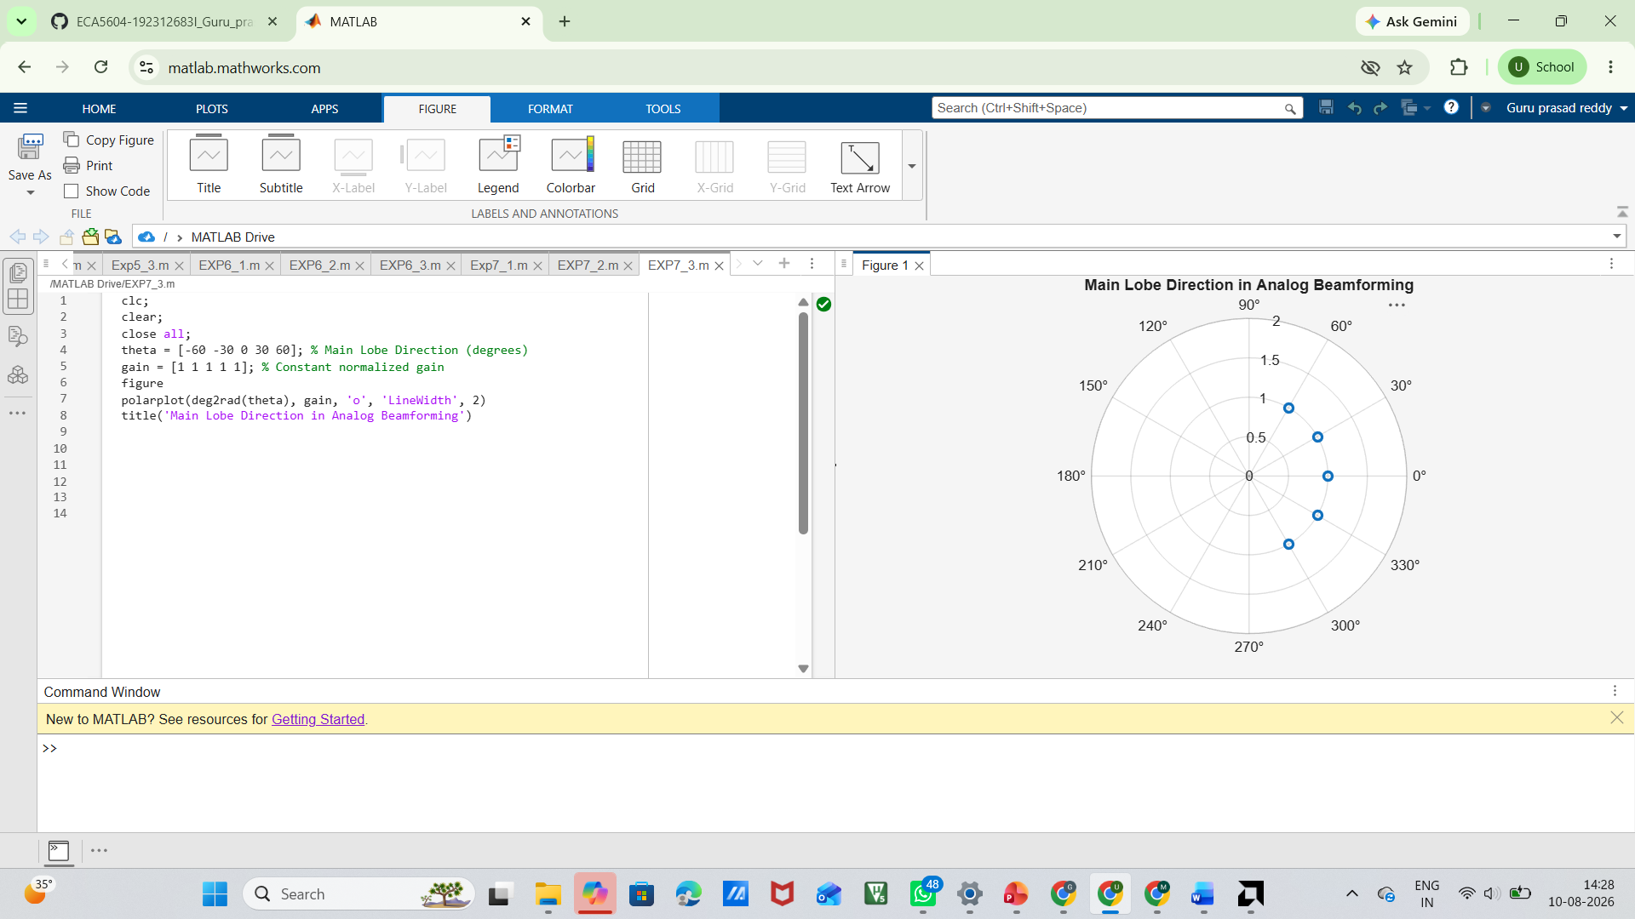
Result:
The MATLAB simulation showed that increasing the number of antenna elements improves the beamforming gain and produces a narrower beam width. It also confirmed that the main lobe can be accurately steered to different directions, demonstrating the effectiveness of analogy beamforming.

